
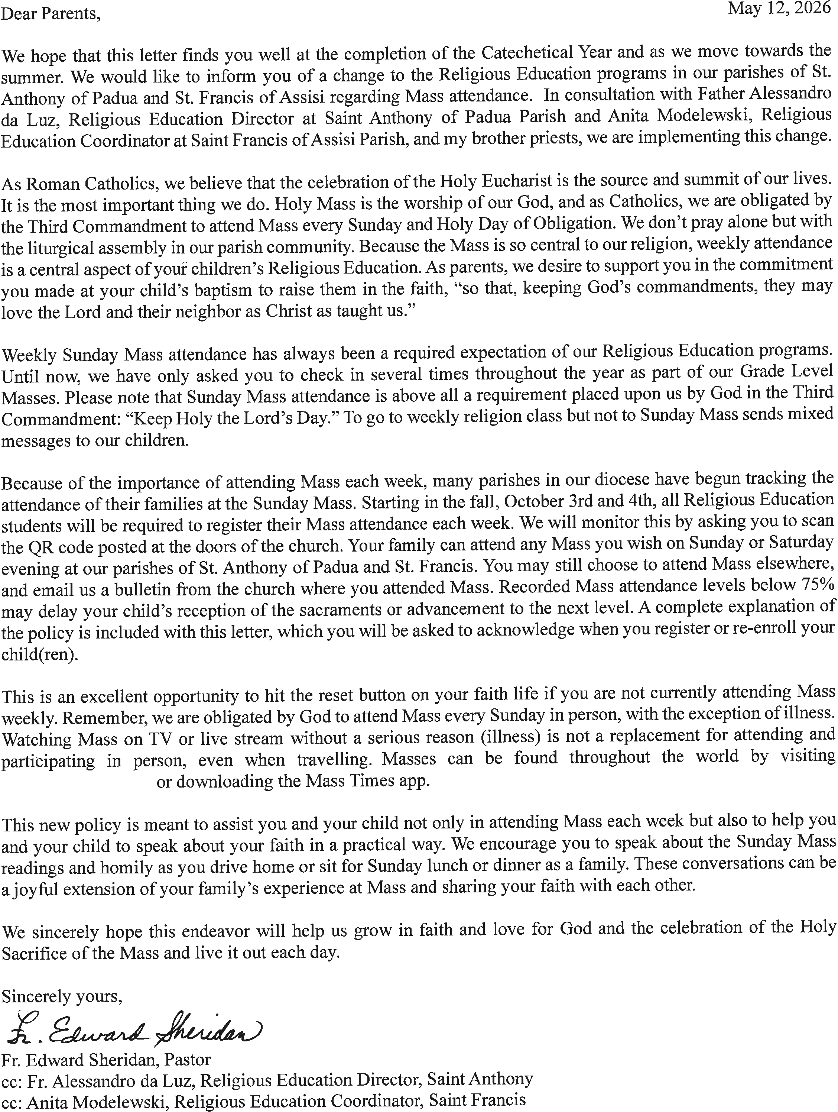

Parishes of St. Anthony of Padua and St. Francis of Assisi
Mass Attendance Policy

As Catholics, we are obligated to attend Mass every Sunday and Holy Day of Obligation. To support this commitment within our Religious Education program, we maintain the following attendance standards for all families.

The Program Requirement
Families are required to attend Mass every Sunday and Holy Day of Obligation year-round.
- The Sunday Mass obligation may be fulfilled with Mass as early as 4:00pm on Saturday through Sunday night.
- In months with 4 Sundays, Mass attendance must be registered at least 3 Sundays a month.
- In months with 5 Sundays, Mass attendance must be registered at least 4 Sundays month. • Mass attendance is tracked per family to ensure we are growing together in faith.

How to Register Your Attendance

Option A: Attending Mass in our parishes
When your children are attending Mass with you, scan the QR code at the doors of the church (St. Anthony of Padua or St. Francis of Assisi).

Option B: Attending Mass elsewhere
If your family attends Mass outside of St. Anthony’s or St. Francis, you are responsible for updating your records as soon as possible by emailing us a photo of the Mass bulletin with your children’s names, the Mass time, and the name of the priest who celebrated Mass. Please be prompt in sending us the bulletins. Bulletins older than 3 weeks will not be accepted.

Clear Communication
If due to some serious extenuating circumstance, such as illness or death in the family, you will miss more than one Mass in a month, please contact us by email.

Failure to Complete the Requirement
If your family does not maintain 75% registered Mass attendance, the grade level may need to be repeated and/or reception of the sacraments may be delayed.

Acceptance of the Policy

I have read the above policy regarding Mass attendance. As a family, we pledge to fulfill the obligation given to us by God in the Third Commandment to “Keep holy the Lord’s Day” by attending Mass each Sunday and Holy Day of Obligation.

I understand that if we do not meet the requirements of this policy, that my child(ren) may have to repeat a grade level or have reception of the sacraments delayed.

Parent Name: ______________________________________________________________________________
Child(ren)’s Name(s): ________________________________________________________________________
Signature: _________________________________________________________________________________
Date: ___________________________________________

Additional Information

Mass Attendance
Mass attendance is at the center of everything we do as Catholics and is the most important component of our Religious Education program. It is critical that we go to Mass every Sunday to be nourished by the Word of God and the Holy Eucharist. The Mass is where we encounter Christ in a profound way. This weekly encounter strengthens our faith, provides spiritual sustenance, and deepens our relationship with God.

Recent data shows that less than 20% of Catholics attend Mass each weekend. Less than 10% of Catholics in their 40s attend Mass each weekend. This is the age of many of the parents of children in Religious Education programs.

Accountability for Mass attendance has always been a part of our Religious Education program. Going forward, we have a way to effectively track attendance when you go to Mass. Rather than filling out weekly Mass reflections or bringing in bulletins, the QR code will simplify tracking Mass attendance.

Frequently Asked Questions

- Doesn’t this system seem a little punitive or like you are monitoring us like “big brother?”

The purpose of using the QR code system is not meant to be punitive at all. We are all obligated as Catholics to attend Mass every Sunday and Holy Day of Obligation. The Third Commandment is to “Keep holy the Lord’s Day,” calling us to dedicate this day to God (Exodus 20:8, Deuteronomy 5:12). This obligation is also affirmed in the Catechism of the Catholic Church (2180), which states, “On Sundays and other holy days of obligation the faithful are bound to participate in the Mass.”

We are not trying to monitor families like “big brother.” This system is simply the most efficient way for us as a parish staff to take attendance and allow for families to go to any Mass on the weekend that best suits their schedule, while still fulfilling their obligation.

- The weekends are really busy for us as a family. Can we go to Mass during the week to make up for missing Sunday Mass?

While attending Mass during the week is a wonderful spiritual practice, it does not fulfill the Sunday obligation. The Church teaches that the Sunday obligation may be satisfied beginning at 4:00pm the evening before, ending with Midnight the day of (Catechism of the Catholic Church 2180; Code of Canon Law 1247-1248). This means that only Masses celebrated within this specific time frame, or designated holy days of obligation, fulfill the precept.

- Taking my children to Mass each Sunday is a responsibility of mine as a parent, and it is my choice to take them each weekend or not. Do you really have a right to tell us we must go each weekend?

Yes, it is indeed a primary responsibility of parents to raise their children in the faith and bring them to Mass. As a Religious Education program and part of the Catholic Church, our role is to support you in fulfilling this vital duty and ensure that children are truly prepared to receive the sacraments. Attending Mass is the “source and summit” of our faith (Sacrosanctum Concilium 10), where Christ himself is present. Regular participation is therefore necessary for children to grow spiritually and to be properly prepared for reception of the sacraments like Holy Communion and Confirmation. We cannot, in good conscience, present children for sacraments if they are not participating in the very heart of our Catholic life. We must uphold the dignity of the sacraments and the integrity of our Religious Education.

- My family travels frequently or has other unavoidable commitments. How will this new system accommodate occasional absences?
We understand that life can be busy, and occasional absences are sometimes unavoidable due to illness, and other extenuating circumstances. This system is designed for accountability and support, not punishment. We ask that families make every reasonable effort to attend Mass each Sunday.

If you will be traveling, please check www.masstimes.org or download the MassTimes app where you can find Catholic Masses all over the world. You may register your Mass attendance by emailing us a photo of the bulletin.

In the event of illness or another serious circumstance such as a death in the family, please email us to keep us informed. We appreciate open communication and trust our families to uphold their commitment to Religious Education. We are here to support you in fulfilling your Sunday obligation.

- How can we help our children understand the importance of Mass attendance, especially with this new system, rather just seeing it as a “check the box” requirement?

That’s a very important question and the answer is at the heart of our faith. The QR code system is an administrative tool to help us track attendance. The spiritual significance of the Mass remains paramount. When you go to Mass with your children focus on the meaning and beauty of the Mass itself. Speak with them about the importance of receiving Jesus in the Eucharist, listening to the Word of God, and being part of our parish family. The Mass is the most joyous and powerful thing we can participate in. God comes to us in the Eucharist and we get to receive him. Explain that attending Mass is not just a rule, but a joyful opportunity to meet and praise God and to receive his grace. Consider arriving a few minutes early to prepare, or staying a few minutes after to reflect and pray in thanksgiving. Engage your children at lunch or dinner or on the car ride home talking about the Gospel reading and homily. Your example and enthusiasm are the most powerful teacher in helping your family see Mass as a vital and cherished part of our Catholic life, far beyond attendance tracking.

